QUALITY IMPROVEMENT PROJECT REPORT TEMPLATE

Submission Instructions: Email this document to your assigned Quality Coach and cc RW.Quality@dc.gov and your assigned Program Officer.

Directions: Use this Plan Do Study Act (PDSA) tool to plan and document your Quality Improvement Project (QIP).

Agency Name:

Project Lead:
Reporting Quarter | Start Date: | End Date: | Report Due Date
☐ Quarter 1 | Jun. 1, 2025 | Aug. 31, 2025 | Oct. 1, 2025
☐ Quarter 2 | Sept. 1, 2025 | Nov. 30, 2025 | Jan. 1, 2026
☐ Quarter 3 | Dec. 1, 2025 | Feb. 28, 2026 | Apr. 1, 2026

AIM STATEMENT

Develop the components of your AIM statement using the SMART framework (WHAT YOU ARE TRYING TO ACCOMPLISH):

- Specific- targeted population:

- Measurable- what is being measured:

- Achievable- within your capacity and resources:

- Relevant- why is it important to do now:

- Time - a specific timeframe:

Use the information above to create your project Aim Statement (e.g., Our agency will increase the percentage of Ryan White customers achieving viral load suppression by the end of Quarter 2):

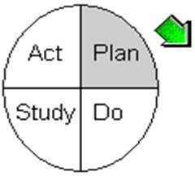
PLAN

In this section, think about what changes you can make that will result in improvement and how you will know the change is an improvement.

What change (intervention) will be tested or implemented?

How will the change be conducted? (Include specifics on tasks, responsibilities and due dates):

Name all people involved in this QIP and their title/role:

Prediction (What should happen after implementing the above intervention):

Data Collection Plan

What performance measure(s) will be tracked (e.g., viral load suppression, wait times, screenings, etc.)?

To track the progress of your QIP, you must define the denominator and numerator for your performance measure(s).
For reference:
- Denominator: represents the total group being measured (e.g., total number of Ryan White customers at the clinic)
- Numerator: the subset of the denominator that meets the desired outcome/goal (e.g., number of those Ryan White customers who achieve viral load suppression)

In the space provided, clearly define the project numerator and denominator:

Numerator:

Denominator:

Who will collect the performance measure data?

When will the collection of performance measure data take place?

What decisions will be made based on performance measure data?

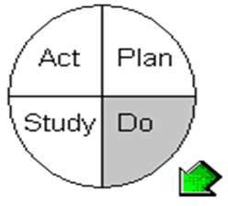
DO

Activities/Observations
Describe what actually happened when the intervention was implemented (record activities/ observations that were done):

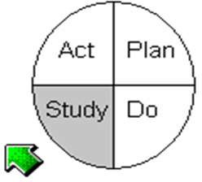
STUDY
Analyze the data

Directions:
Use (1) of the tables below to appropriately track your QIP performance measure data. If needed, reference Data Collection Plan section. The examples in red within the charts are provided as a reference.

Definitions
Baseline: Initial set of data collected before intervention begins. It serves as a reference point (i.e., data from the previous Grant Year).
Target: Attainable goal or desired outcome for your QIP performance measure data.
Table for reporting performance measure data as percentages:
Use this table if you are reporting your performance measure as a percentage.
Quarter | Baseline | Numerator (n) | Denominator (d) | Percentage (n/d x 100) | Target
Example | 25% (customers virally suppressed) | 40 (customers virally suppressed) | 100 (customers total at the clinic) | 40/100 = 40% (of customers virally suppressed) | 75% (of customers virally suppressed by end of QX)
Quarter 1
Quarter 2
Quarter 3

OR

Table for reporting performance measure data as numbers:
Use this table if you are reporting your performance measure as a number instead of a percentage.
Quarter | Baseline | Number | Target
Example | 25-minute wait time (for customer) | 15-minute wait time (for customer) | 10-minute wait time (for customer by QX)
Quarter 1
Quarter 2
Quarter 3

Data Narrative
How does your data compare to the predictions or previous quarter data?

What unintended consequences, surprises, successes, or failures occurred?

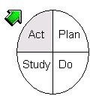
ACT

Describe the next PDSA cycle

Based on what is next for the QIP?

Will you (Choose one and explain):

- Adapt (e.g., modify the changes and repeat):

- Adopt (e.g., implement or integrate into your organization or standard processes):

- Abandon (e.g., discontinue and plan a new intervention):

